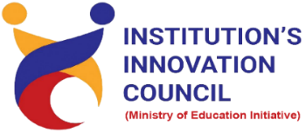
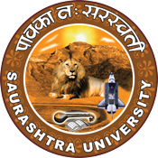

Institution's Innovation Council
Saurashtra University

Sensitization of SSIP 2.0
“Mind to Market”
11 January 2023
At
Seminar Hall, Department of Human Rights & IHL,
Saurashtra University, Rajkot
Contents
Saurashtra University – IIC 2
i-Hub 2
Event Schedule 2
Event Registration Link 2
Brief about Event 3
Key Points 3
Outcome 4
About the Speaker/Chief Guest 5
Connect Us: 7

Saurashtra University – IIC

The university is dedicated to instruction, research, and extending knowledge to the public (public service). Ministry of Education (MoE), Govt. of India has established ‘MoE’s Innovation Cell (MIC)’ to systematically foster the culture of Innovation among all Higher Education Institutions (HEIs). The primary mandate of MIC is to encourage, inspire and nurture young students by supporting them to work with new ideas and transform them into prototypes while they are informative years. Saurashtra University is one the Organization that have constituted the IIC to foster the vision of MoE and be a part for the promotion and development of innovation ecosystem.

i-Hub

Gujarat Student Start-up and Innovation Hub, registered under Section 8 of the companies Act 2013, is envisioned to be centre for all Start-up stakeholders to develop an end-to-end innovation and entrepreneurial ecosystem in the State of Gujarat by creating pathways from “Mind-to-Market”. i-Hub is a vibrant incubation setup established under SSIP by the Education Department, Government of Gujarat.

Event Schedule

11:00

Welcome

11:05

Awarness Session

12:30

Q n A

12:45

Closing Ceremony

Event Registration Link

bit.ly/MTM-SSIP

Brief about Event
With a perspective to upgrade the skills of SSIP Coordinators and Innovative students SU Start-up And Entrepreneurship Council (SUSEC) in Association with i-Hub organized one-day Sensitization Program on "Mind to Market" on January 11, 2023 Wednesday. That was an exclusive event for start-ups, SSIP coordinators, students and new age entrepreneurs from the Gujarat start-up ecosystem.
The Student Start-up & Innovation Policy of Government of Gujarat aims to create an integrated, state-wide, university-based innovation ecosystem to support innovations and ideas of young students and provide a conducive environment for optimum harnessing of their creative pursuit.

In Sensitization of SSIP 2.0 program we understood Financial Support Structure in that the Student Start-up and Innovation Policy (SSIP 2.0) provisions for creation of a Student Innovation Fund (SIF) and Grantee Matching Fund (GMF) of Rs.500 crore for the period of the policy. Rs. 300 crore (SIF) shall be provisioned through state budget for the policy period, whereas the remainder of Rs. 200 crore (GMF) shall be mobilized via existing resources such as internal budgets of universities/institutes, private and CSR funds and others.

This program will bridge the gap between academia and industry transforming the research into market-ready products/services. It aims to convert translational ideas into products/services considering the sector-specific industrial problem statements. Best proposals/ideas/concepts to avail financial assistance up to 2.5 Lacs and mentorship support for pursuing the proposed solutions
This program objectives is to solve industries and corporates' pressing problems with the help of the creative minds of students, start-ups & innovators. At the same time enable and encourage them to be involved in the Innovation and start-up ecosystem to drive the nation’s growth.

Key Points

During the session, below mentioned points were discussed:
- SSIP 1.0 & 2.0 Comparison
- Salient Features of SSIP 2.0
- Eligibility to receive SSIP 2.0 Grant
- IPR Support
- Start-ups at i-Hub
- State Intellectual Property Facilitation Center (IPFC)
- Financial Support for IP filing and Prosecution
- Mind to Market (M2M) Open Innovation Challenge
- Road Map of Mind to Market Innovation Challenge
- M2M Innovation Challenges and Partners
- Startup Srujan Seed Support (S4)
- FAQs related to Sensitization of SSIP 2.0 was discussed

Outcome

As per the event, SSIP 1.0 & 2.0 were understood by the speaker with various examples.
Mind to Market is a pre-seed fund investing in start-ups with high growth potential at the very earliest stage. Also, as it was related to Intellectual property and awareness creation, a basic knowledge of intellectual property, how it works, how it can be registered, with various examples. We found that M2M initiatives help us develop a responsive eco-system to engage and empower India's youth to contribute their ideas.
We know the financial support structure and eligibility criteria for schools, institutes, universities and individual beneficiaries to get SSIP 2.0 grants.

About the Speaker/Chief Guest
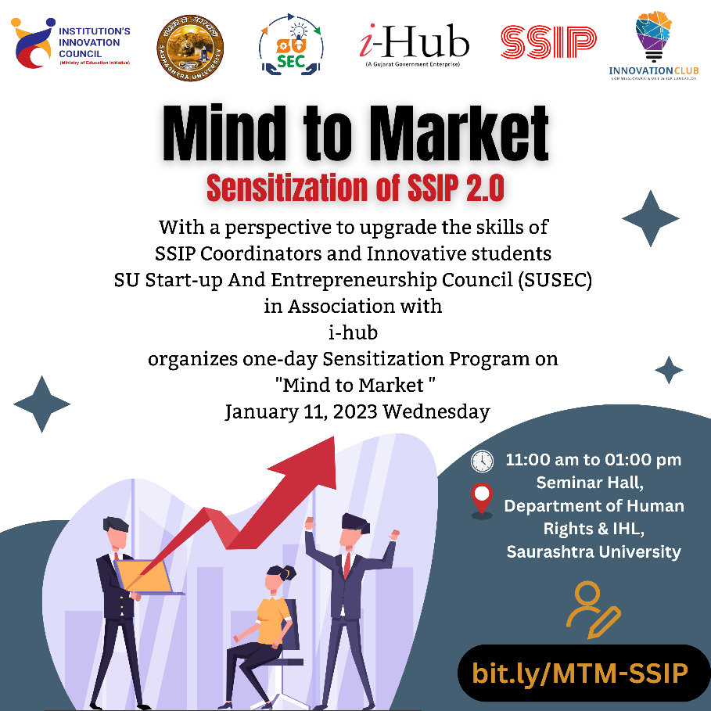

Mr. Mitesh Vadher

Assistant Incubation Manager

i-hub Ahemdabad

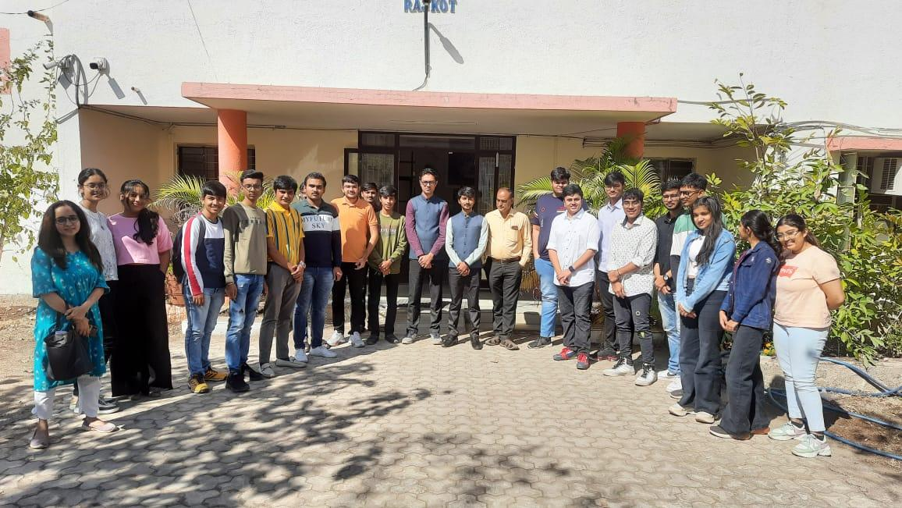
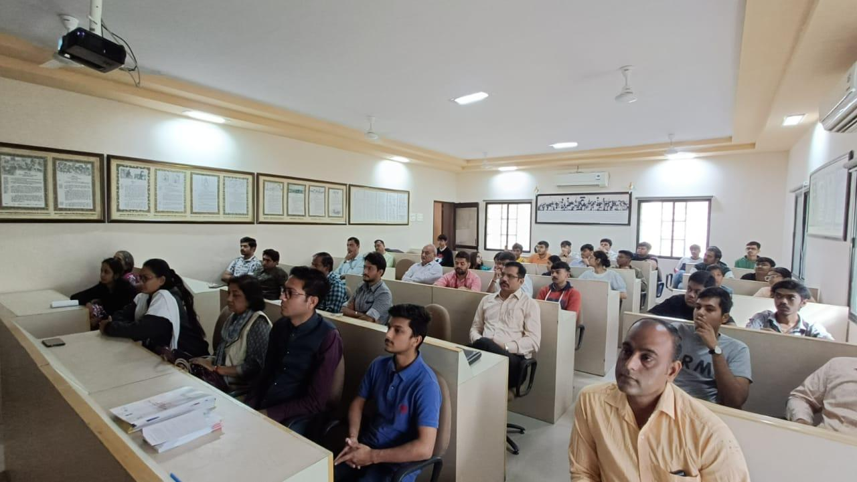

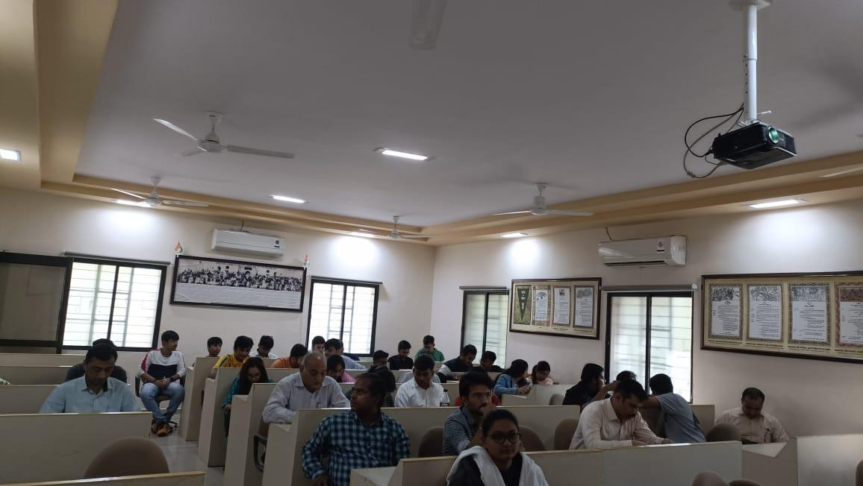
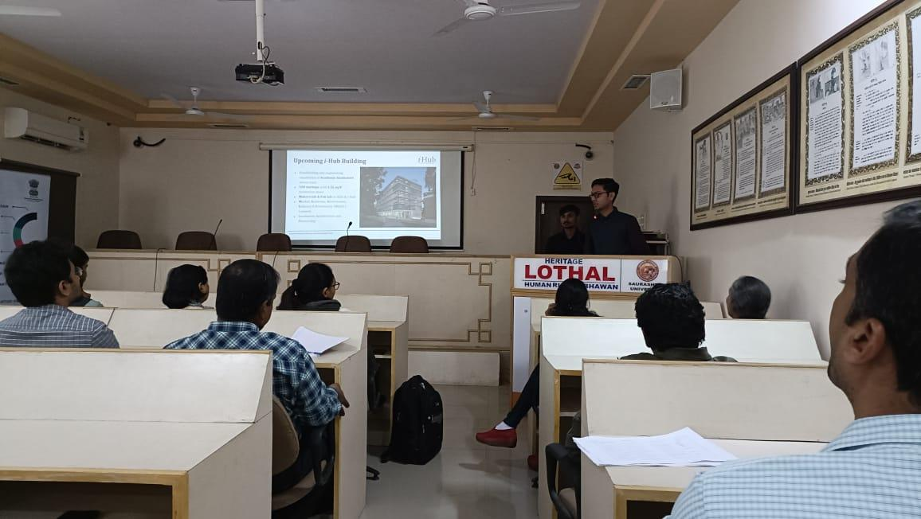

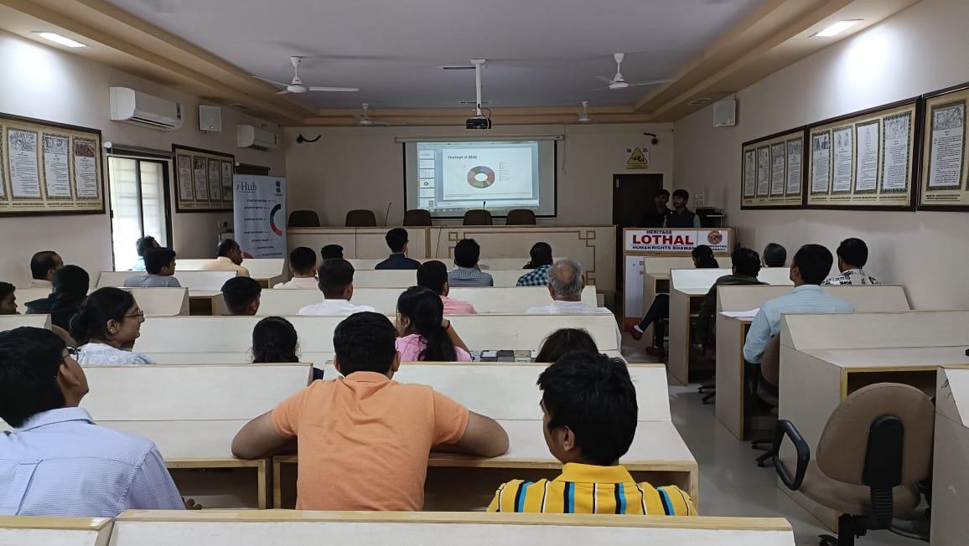
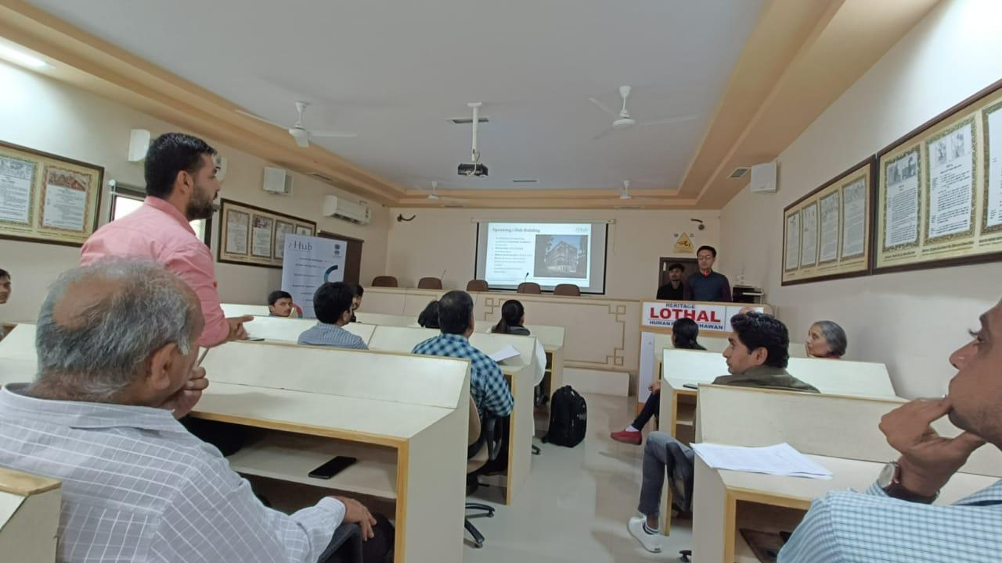

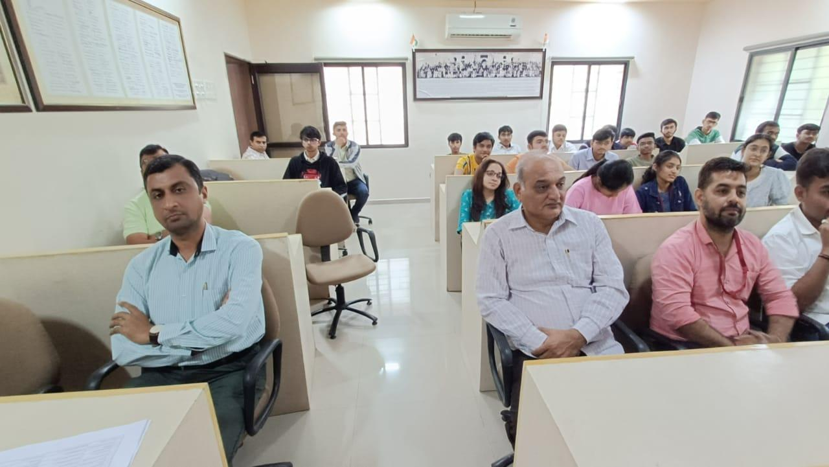
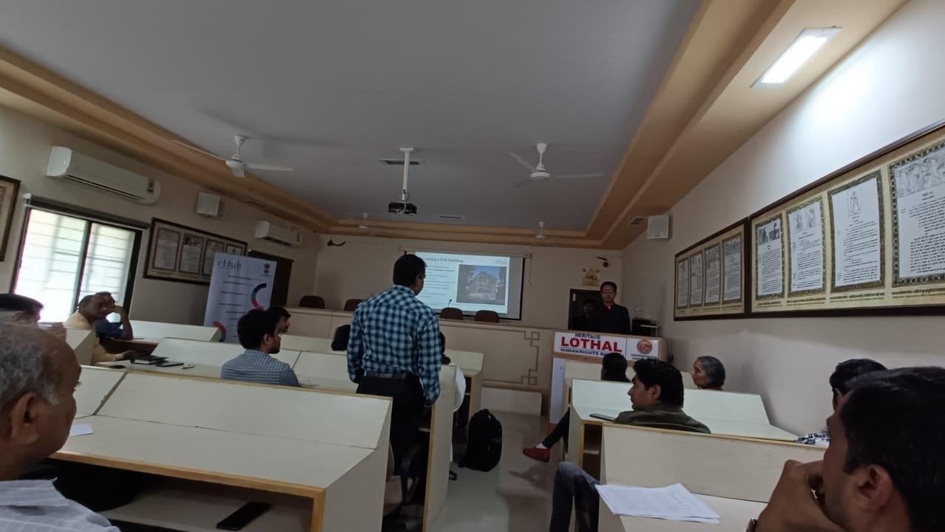

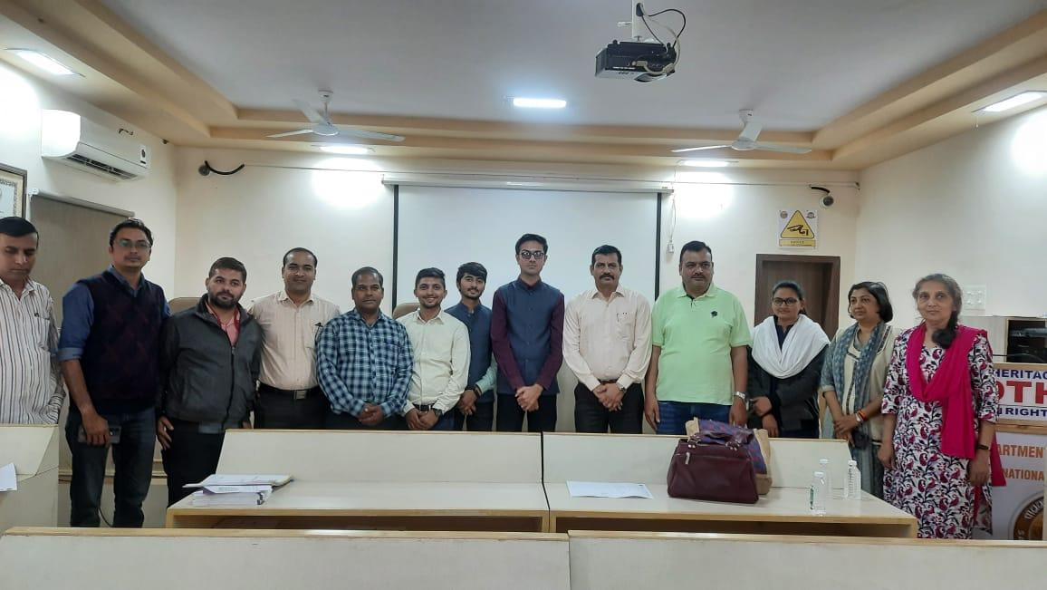

Connect Us:

https://www.linkedin.com/company/susec iic@sauuni.ac.in
https://www.facebook.com/iicsauuni bit.ly/SU-SSIP Location
https://www.instagram.com/susecrajkot

